Summer 2015  Issue 60 | Exeter, Mid and East Devon Patients and Carer’s Cancer Support Group
OPA
Oesophageal Patients Association Registered Charity No. 1062461

As this is a special year for the OPA, I have left the Pearl Anniversary logo to remind us all of the massive support that it gives us. The Group will be making a donation to OPA to help continue their work later this year.

MONTHLY MEETINGS - looking forward
These take place on the last Friday of every month from 1.00 – 3.00pm at the Force Centre in Exeter, These meetings provide an opportunity to meet informally, enjoy a hot drink, listen to a speaker, occasionally have a quiz, ask questions and finish with a raffle.

Meetings for the next four months are as follows:
31st July. Vicky Lachenicht from Hospiscare will be speaking to us, telling us about the work that Hospiscare does in the community. We also have James Garnett, the RD&E photographer, coming to the meeting (complete with his camera) to take photos and to get some information for him to publish in the RD&E newsletter.
28th August. August is usually a quiet month, so we will probably have an open meeting, with plenty of time for questions and answers.
25th September. Roland Newbold, one of our members who lives in Bournemouth, is travelling over to join us and share a talk with us.
30th October. The Exeter Oddfellows are hoping to join us to talk more about their work. (see the article later in the newsletter).

REGIONAL MEETING 9th May
Alan Willson started the meeting by reminding us about the Pearl anniversary of OPA and confirmed that the new Chairman, Bob Mason, will be the guest speaker at our November Regional meeting on November 7th, at the Kenn Centre.

Alan then introduced our speaker Keith Mitchell who talked about ‘Survivorship’. There have been many improvements in care over the last few years, with earlier diagnosis, better drugs and improved treatment. Now there is a need to develop a personal plan for each patient with a tailoring of care to suit individual needs. Patients are identified as low/medium or high risk and follow-ups and their frequency can be sorted out at the time of surgery. There is a push to reduce the number of hospital visits when, for example, blood tests can be taken at the local surgery and forwarded to the hospital, thus removing the need for long journeys and waiting for appointments.

After this excellent talk, Bill Baker presented Keith with a retirement gift, following his move from Senior Nurse for Cancer Services to his new role as Project Nurse. We were delighted to present him with a model of a yacht, with a plaque thanking him for all his years of dedicated service to all of us. We all wish Keith the very best in his future role. | 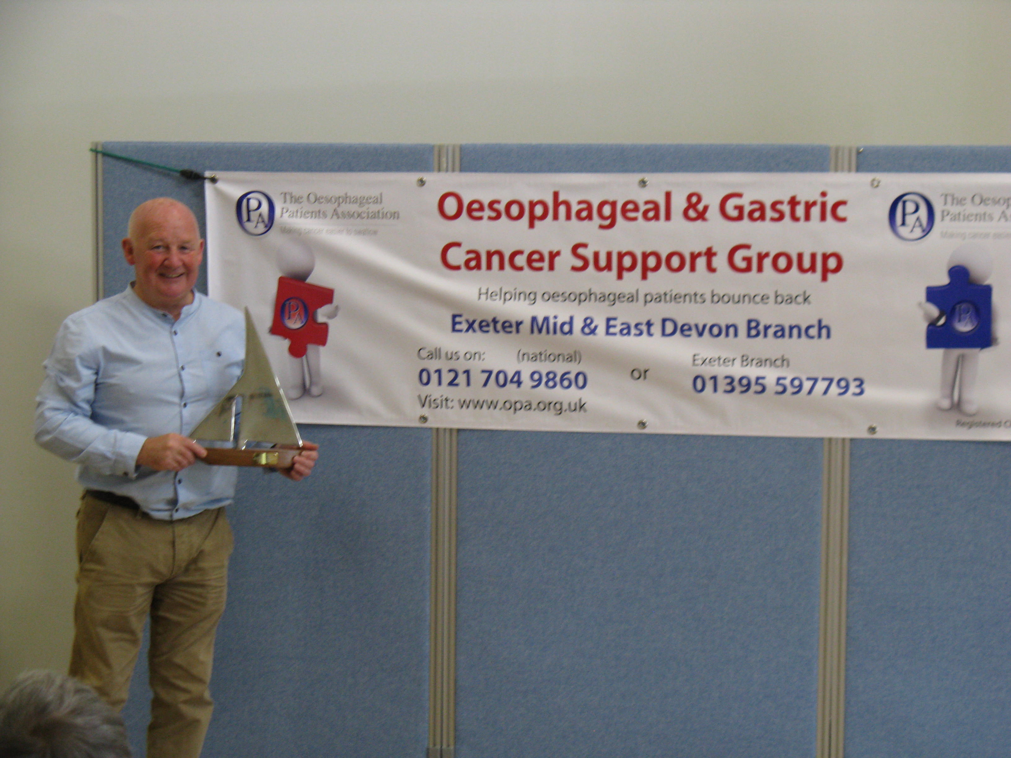

Marilyn Bolter, Specialist UGI Nurse at Plymouth Derriford Hospital joined Keith for a Question and Answer session with an opportunity for us all to pick their brains on a wide range of issues and problems.

We had our first cake sale and members donated some delicious home made cakes which quickly sold raising £37.20 for our funds. Many thanks to all those friends who kindly donated cakes for the sale.

Following the meeting, ten of us went to the Devon Hotel for lunch. This was an opportunity for more chat in pleasant surroundings. We all agreed it has been a great Regional meeting.

annual outing – june 26th
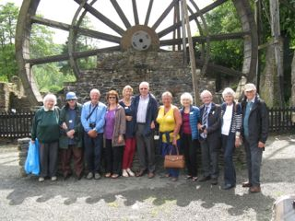 | EXETER, MID AND EAST DEVON OPA 2015 ANNUAL OUTING.  On 26th June some members of the Exeter OPA made their way to Morwellham Quay for the group's annual outing.  Morwellham Quay is an old Copper Mine complete with period living accommodation and a school. We started the day here and the very convincing school mistress gave us a hard but amusing time. There followed a tour of the
mining cottages and an insight into the processing of the copper before shipment for smelting. We broke for a very satisfactory lunch before proceeding to the mine entrance. A little train provided access to the mine. Once inside the mine we saw the working conditions that the miners endured which made us feel that we are definitely living in better, if not perfect times. After the mine trip some of the ladies in our party enjoyed a hilarious half hour, donning costume of the day and admiring themselves in the mirrors provided.

Around mid afternoon, having all agreed that Morwellham was a good choice we made our way home. The weather had been reasonably kind to us and did not impede our activities in any way.

Thanks must go to Karen and Barry for their perfect organisation of this memorable trip.
Report by Colin Cruickshank

exeter oddfellows
You may remember in the Spring newsletter I reported that the Exeter Oddfellows have kindly nominated the Exeter branch of The Oesophageal Patients Association as their Charity of the Year  We have received another generous donation of £40 from them as part of their support to the Exeter OPA for 2015.  The picture shows Margaret and Peter Clarke and their books and bric-a-brac stall at the Cullompton Town Fair.  We are hoping they will join us at our October monthly meeting so we can understand more of their work and their organisation.  Thank you Oddfellows for your continuing support.  Report by Bill Baker | 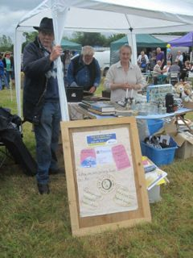

FUNNY BONE CORNEr – quick quips
I was driving this morning when I saw a parked RAC van. The driver was sobbing uncontrollably and looked very miserable. I thought to myself, that guy's heading for a breakdown.

My neighbour knocked on my door at 2:30am this morning, can you believe that, 2:30am! Luckily for him I was still up playing my bagpipes.

The wife has been missing a week now. Police said to prepare for the worst. So I have been to the charity shop to get all her clothes back.

I bought some 'rocket salad' yesterday but it went off before I could eat it!

sponsored bike ride
You may remember from the Spring newsletter that Matthew Baker was going to undertake a challenging fund raising bike ride sponsoring the OPA in their Pearl celebration year.

On 31st May Matthew went out on his bike, cycling and puffing his way over 110 miles through the Chilterns. He successfully completed his challenge and raised the magnificent sum of £1,100.

Thank you Matthew for your wonderful support for our very worthwhile charity.

OCCAMS & ROMIO TRIALS
We have been contacted by an Upper GI Research Practitioner who is currently working on the OCCAMS and ROMIO trials for Oesophageal cancer. The OCCAMS Trial is looking at the genetic make up of Adenocarcinoma of the oesophagus and ROMIO is comparing open versus the keyhole approach to oesphagectomy. The Research Practitioners are interested in attending the monthly OPA meeting in Exeter, and we look forward to meeting them and hearing what they have to tell us of their research, and I’m sure they will find our input helpful also.

doctor doctor CORNer
Doctor, Doctor I keep thinking I'm a dog
Sit on the couch and we’ll talk about it.
But I'm not allowed up on the couch!

Doctor, Doctor I've had tummy ache since I ate three crabs yesterday.
Did they smell bad when you took them out of their shells?
What do you mean "took them out of their shells!"

If you would like to include an item or photograph for the Autumn issue, please would you email them to brian.marionk2@tiscali.co.uk by the end of September. You can also drop me a line at 16 Trelivan Close, Exmouth, EX8 5RJ. My phone number is 07710 286204.
Brian Kohl, secretary

